**NOTICE TO ADJACENT PROPERTY OWNERS**

**SITE WALK & DESIGN CHARETTE**

In accordance with the Town of Weddington Unified Development Ordinance (UDO) Section D-607(C)(3)(a) Keystone Custom Homes will hold an On-Site Visit and Design Charette for adjacent property owners on approximately 16.6 acres located at 3009 Forest Lawn (parcel numbers 07150015). These parcels are currently zoned R-CD-no change in zoning designation is anticipated.

Tuesday April 29, 5:30-6:30

Site Walk at 3009 Forest Lawn Drive

Charette immediately following at Town Hall 1924 Weddington Road

Any questions please email: Casey Whiteman, Colliers Engineering & Design [casey.whiteman@collierseng.com](mailto:casey.whiteman@collierseng.com) OR

Keith Fenn, Keystone Custom Homes

kfenn@keystonecustomhome.com

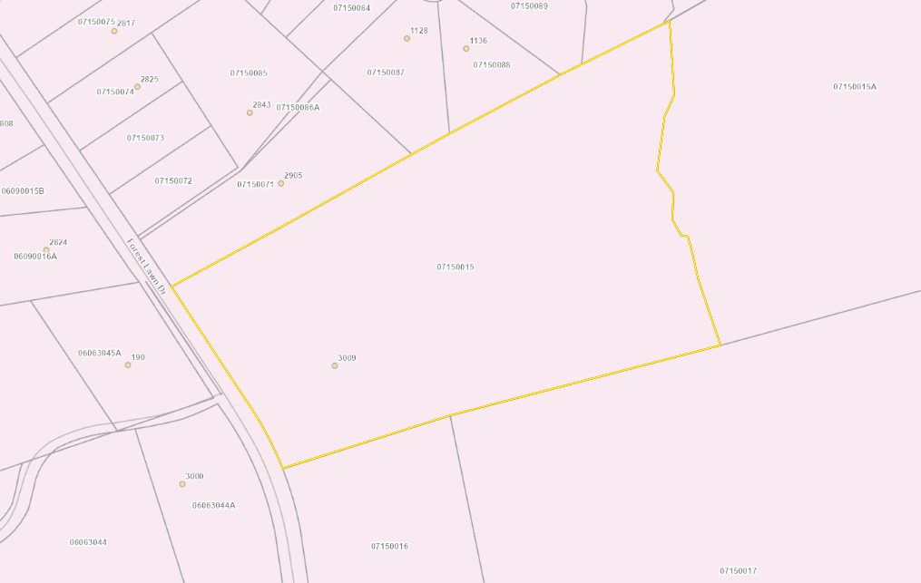

**There may be a quorum of the Council and Planning Board.

*UDO Section D-607(C)(3)(a). On-Site Visit/Charrette. After preparing the existing resources and site analysis map and prior to the submission of the site plan, the Applicant shall schedule time to walk the property with the Administrator, Planning Board members, and adjacent property owners. The purpose of this visit is to familiarize staff and Planning Board members with the property's special features, and to provide them an informal opportunity to offer guidance to the applicant regarding the tentative location of secondary conservation areas, potential house locations and street alignments. A notice giving the date, time and purpose of the meeting shall be sent by the Town to adjacent property owners at least ten days prior to the site walk. The Applicant shall distribute copies of the existing resources and site analysis plan at the on-site meeting. Applicants, their site designers, and the landowner shall participate to show the Town the property's special features. Comments made by town officials or staff and consultants shall be interpreted as being only suggestive and advisory. It shall be understood by all parties that no formal recommendations can be offered, and no official decisions can be made during this on-site visit. ***It is a work session of the Planning Board and is duly noticed in the standard manner for all public meetings.***