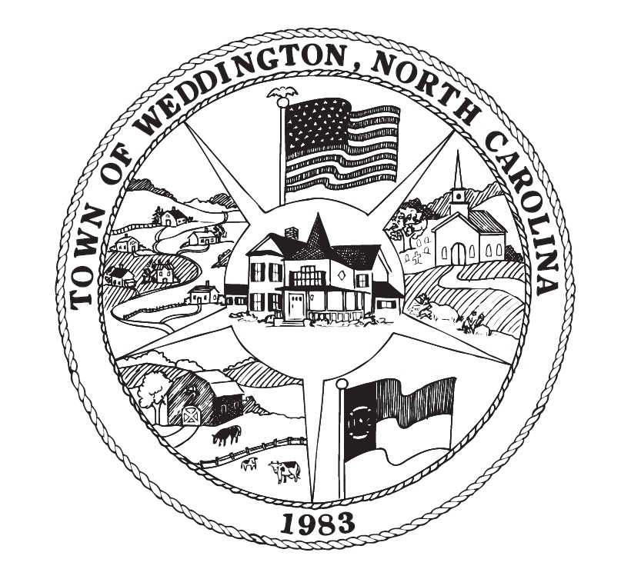

SPECIAL MEETING NOTICE

Mayor Callis has called for a Special Meeting to be held at Weddington Town Hall at 1924 Weddington Road Friday March 22, 2019 at 3:30 p.m. for the purpose of discussion of recommended revisions to the Town Lighting Ordinance.

Please contact the Town Clerk at (704) 846-2709 for additional information. The Town Hall is open Monday, Wednesday, and Friday – 9:00 a.m. to 1:00 p.m.

Special Town Council Meeting
Friday March 22, 2019
3:30 p.m.

Agenda

- Adoption of Agenda

- Discussion of Recommended Revisions to the Town Lighting Ordinance

- Adjournment

_______________________
Elizabeth Callis, Mayor

