REQUEST FOR PROPOSALS
TO PROVIDE
LEGAL SERVICES

January 19, 2018

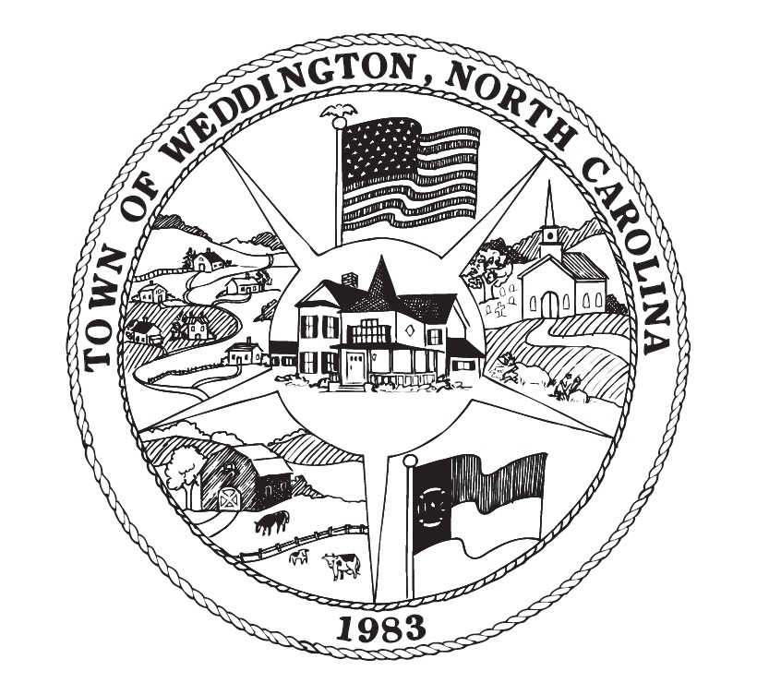

TOWN OF WEDDINGTON
NORTH CAROLINA

The Weddington Town Council is accepting applications from those interested in serving as Town Attorney. Licensed attorneys who wish to be considered for the position should submit an application to Town Administrator, Town of Weddington, 1924 Weddington Rd., Weddington, NC 28104. The deadline for applications is Wednesday, February 21, 2018.

TOWN OF WEDDINGTON, NORTH CAROLINA
ATTORNEY SERVICES

OVERVIEW

The Weddington Town Council has directed the Town Administrator to solicit proposals from those individuals interested in serving as Town Attorney. The Town of Weddington operates under the Mayor-Council form of government. Under this form of government, the Town Attorney is appointed by the Council. There is no specified term for the Town Attorney’s service to the Town. The Town Attorney will provide general legal counsel to the Council, Mayor, Town Administrator, and Town staff, and, if necessary, will provide legal counsel to the Town as plaintiff or defendant. A cooperative working relationship among the Town Attorney, Council, Mayor, Town Administrator, and Town staff is essential.

The purpose of all submitted proposals is to demonstrate the qualifications, competence, depth, and capability of the firms seeking to provide legal services to the Town of Weddington in conformity with the requirements of this request for proposals. The proposal should address all the points outlined in the request for proposals. The proposal should be prepared simply and economically, providing a straightforward, concise description of the firm’s capabilities to satisfy the requirements of the request for proposals.

SCOPE OF SERVICES, DUTIES AND RESPONSIBILITIES

Typical responsibilities of the Town Attorney will include:
- Attendance at the monthly Town meeting (Typically the second Monday of the month)
- Attendance at special-called meetings, as needed
- Legal advice and other legal services as requested by the Council, Mayor, and/or Town Administrator
- Draft and/or Review of official Town contracts, Ordinances, Resolutions, Special Legislation, Bylaws, Forms, Agreements, Policies and Procedures
- Assist in development and review of draft ordinances/amendments prepared by Town staff, prior to consideration by the Council
- Approve all official bonds
- Assistance with real estate transactions, including tax foreclosures, associated with Town projects and/or operations
- Assist in development and review draft or approve deeds, contracts and any other instruments relating to the business of the Town
- Prosecute and defend suits for and against the Town and for and against Town officers acting in their official capacity
- Advise the Mayor, Council and other Town officers as to the compliance with General Statutes and local ordinances
MINIMUM QUALIFICATIONS

- A thorough understanding of the legal framework of municipal government in North Carolina
- Diverse legal experience, particularly in the areas of municipal liability, regulation of new development, public employment law, construction and professional service contracts, and real estate law.
- Prior municipal law experience in service to a North Carolina city, town, or county.
- Accessibility for the Mayor, Council, Town Administrator and designated Town staff as needed.
- Must be in good standing and licensed to practice law in the State of North Carolina as of the date of appointment.
- Must possess J.D. or LLB from an ABA accredit law school
- Five (5) years’ experience in Municipal Law

The Town of Weddington reserves the right to reject all or any part of any or all proposals, to waive technical or legal deficiencies and to accept any proposal that it deems to be in the best interest of the Town. Proposed fees must be firm for one (1) year from acceptance date of proposals with an escalating scale for the next three (3) years.

REQUESTED INFORMATION

While additional data may be presented, the following subjects and questions must be addressed.

- Name, address, telephone number, fax number and email address of firm. Include contact person and telephone number for purposes of following up on proposal.

- Please tell us about your educational background. This should include undergraduate degrees, law degrees and any other degrees which you hold. This might include general information about you, where you grew up and any other information you may wish to share with the Council.

- State the size of the firm, the firm’s municipal law staff, the location of the office from which the work on this position is to be performed and the number and nature of the professional staff to be employed in this appointment.

- Narrative about the history of the firm, including date of inception, experience with relevant North Carolina municipal, state and federal law and their experience performing services to North Carolina municipalities.

- Narrative of the qualifications of the person(s) proposed to work directly with the Town to include:
  - Legal training, years of practice, area of specialization; include date of admittance to North Carolina Bar;
  - Years of municipal, county or state government law practice;
  - Litigation experience and demonstration of a satisfactory court track record;
  - Identify any professional affiliations/detail experience in representing North Carolina municipalities.

- A listing of all previous public sector entities for which the individual or firm has provided legal representation, including dates of service and position held.

- Identify the accessibility of the proposed designated lead Attorney, and the response time that the individual offers to the Town.

- Narrative about the resources of the firm, to include clerical and support staff, library and research capabilities, and other relevant information.

- Describe the level of coverage for malpractice insurance your firm carries and if the coverage is on a per client basis, or is the dollar figure applied to the firm as a whole. Provide documentation of the malpractice insurance coverage.

- State whether within the last five years has your organization, its officers, partners, employees, shareholders or principals been a party in any litigation or other legal proceedings as a defendant relating to the services provided by your entity. If so, provide an explanation and indicate the current status or disposition of any such situation.

- State whether the firm, its officers, partners, principals, agents, or employees, that are expected to perform services under this RFP, have been disciplined, admonished, warned, or had any license, registration, charter, certification, or any similar authorization to engage in the legal profession suspended or revoked for any reason.

- State whether the firm has been in bankruptcy, reorganization or receivership in the last five years. If so please explain current status.

- State whether the firm has been disqualified or terminated by any municipal, county, state government or other public agency. If so, please explain under what circumstances this disqualification or termination occurred.

- Provide a fee schedule and any proposed retainer or fee structure. Also, please provide a concise statement explaining the sole practitioner/firm’s approach and ideas for controlling/limiting the Town’s legal expenses.

- The position of Town Attorney is often contacted by the Town Administrator, Town Clerk, and other staff members and elected officials regarding legal matters. In addition, the Town Attorney attends meetings of the Town Council and other Town meetings as needed. If you were to be on vacation or out for any reason, please explain how Weddington’s legal business will be handled.

- Please provide a statement identifying the sole practitioner/firm’s current clients doing business in and around the Town of Weddington area that have the potential to present a conflict of interest, and the sole practitioner/firm’s approach to avoid potential conflicts of interest. Identify any conflicts of interest that your firm may have in representing the Town of Weddington.

- Please provide a list of references for the Town to contact.

- Please share any other information you feel would be helpful to the Council as they make the decision on the Town Attorney.

- Describe your plan for transitioning from the Town’s current attorney services and how you plan to handle existing lawsuits. Include your estimated time needed for the transition and what type of relationship you anticipate with the current attorney.

The Council will require interviews with firms at their discretion to be held the week of March 5.

INSURANCE REQUIREMENTS

The selected attorney/firm must provide evidence of insurance against claims for injuries to persons or damages to property (including legal malpractice) that may arise out of or in connection with the performance of the contract for legal services, to the extent of the coverage described below. The insurance must name the Town of Weddington as an additional insured and carriers must be acceptable to the Town in order to enter into a contract. These insurance requirements are minimum requirements and in no way limit the indemnity covenants that will be contained in any contracts entered into by the Town and any particular firm or attorney. The Town in no way warrants that the minimum limits identified are sufficient to protect the selected attorney/firm from liabilities that might arise out of the services provided.

Minimum Coverage Requirements:

Worker’s Compensations Statutory
Employer’s Liability $1,000,000
Comprehensive Gen. Liability $1,000,000 per occurrence, $2,000,000 aggregate
Business Auto Liability $1,000,000 combined single limit
Professional Liability $2,000,000 per claim and in the aggregate

It is Weddington’s intent that this RFP shall permit competition. It shall be the respondent's responsibility to advise the Town Administrator in writing if any language, requirement, specification, etc., or any combination thereof, inadvertently restricts or limits the requirements stated in this RFP to a single source. Such notification must be received by the Town Administrator not later than ten (10) days prior to the date set for proposals to close.

SUBMITTAL INFORMATION

Respondents should submit six (6) copies of the requested information to Town of Weddington, Legal Services RFP, 1924 Weddington Rd., Weddington NC 28104. All responses to this solicitation must be received no later than 1:00 p.m. Wednesday, February 21, 2018. These will then be submitted to the Mayor and Council for their review and consideration. Should you have questions or need further information, please do not hesitate to contact our office.

This Request for Proposals is not an offer, obligation, or agreement to award work to any respondent. No contractual relationship is created by responding to this Request for Proposals. The Town of Weddington reserves the right to accept or reject any or all proposals. The Town reserves the right to waive any irregularity, informality, or technicality in proposals received.

