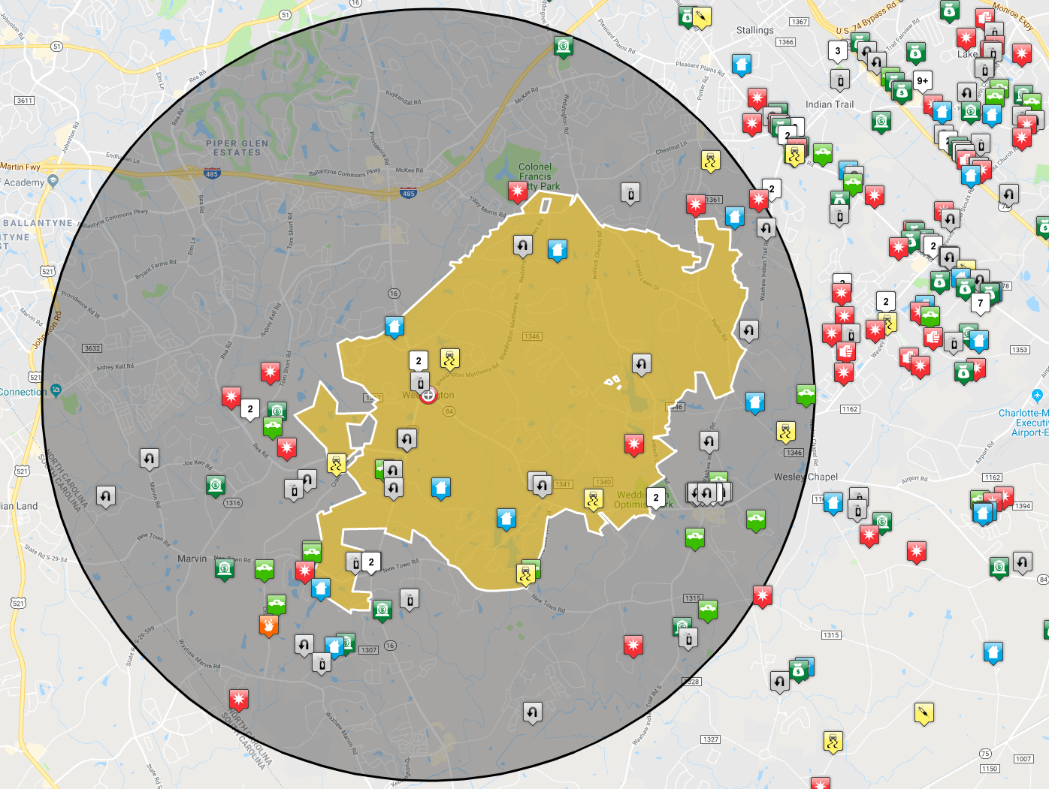
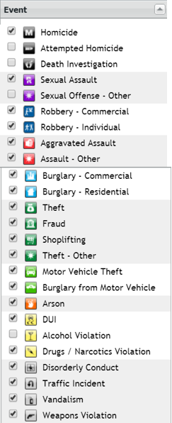
Map Reflects Dates: July 26, 2019 – August 25, 2019 Grey Area is 5 miles from Tow Center Yellow Area is Weddington Town Limits http://unioncountysheriffsoffice.com/crime-mapping

