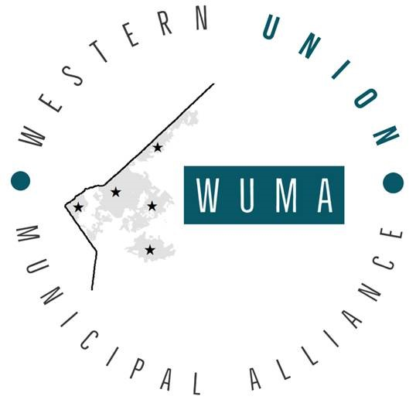

Western Union Municipal Alliance
Regular Meeting
Thursday, October 28, 2021 4:00 p.m.
TOWN OF Weddington
1924 Weddington Road, Weddington, NC

AGENDA

- Open the Meeting and Determination of Quorum

- Adoption of the Agenda

- Approve September 23, 2021 meeting minutes

4. Public Comments

5. Delegate and Municipality Reports

6. Old Business
- Discussion of American Rescue Plan Funds

7. New Business
- Discussion with Jonathon Thomas, Chairman, Union County Planning Board regarding current plans for Extra Territorial Jurisdiction.
- Discussion of Cell Phone Towers

8. Delegate Comments

9. Adjournment

