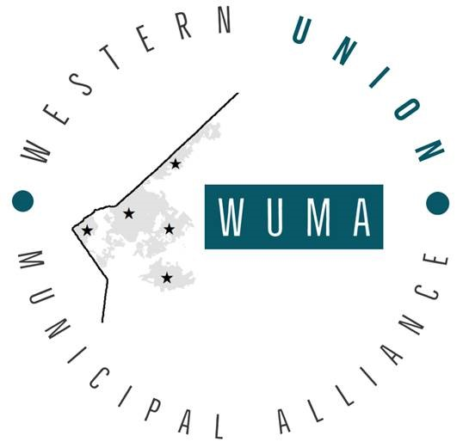
Western Union Municipal Alliance
Regular Meeting
Thursday, February 25, 2021 4:00 p.m.
Wesley Chapel Town Hall
6490 Monroe Weddington Road
Wesley Chapel, NC 28104
AGENDA

- Open the Meeting and Determination of Quorum

- Adoption of the Agenda

- Approve January 28, 2021 meeting minutes

4. Public Comments

5. Delegate and Municipality Reports

6. Old Business
  - Communication with County Planners

7. New Business

8. Delegate Comments

9. Adjournment

