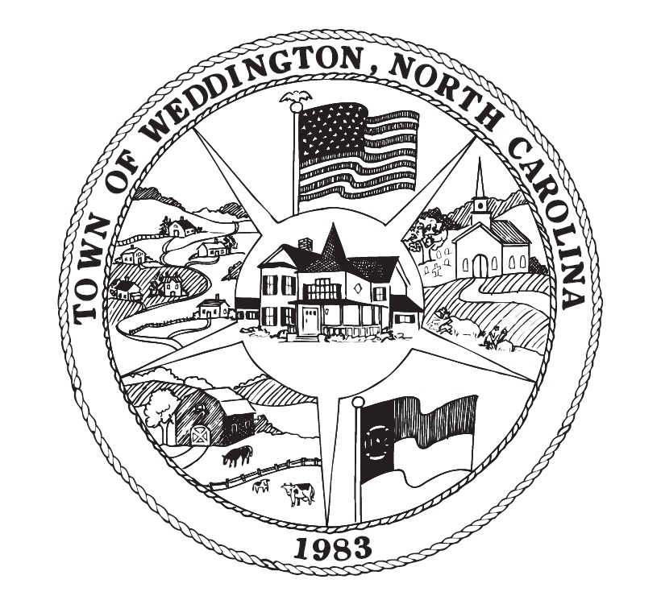

SPECIAL MEETING NOTICE

Mayor Callis has called for a Special Meeting to be held at Weddington Town Hall at 1924 Weddington Road Wednesday, October 24, 2018 at 4:30 p.m. for the purpose of holding a closed session meeting pursuant to NCGS 143-318.11 (A)(3): To consult with attorney on matters protected by the attorney-client privilege relating to Providence Volunteer Fire Department versus Town of Weddington.

Please contact the Town Clerk at (704) 846-2709 for additional information. The Town Hall is open Monday, Wednesday, and Friday – 9:00 a.m. to 1:00 p.m.

Special Town Council Meeting
Weddington Town Hall
Wednesday, October 24, 2018
4:30 p.m.

Agenda

- Adoption of Agenda

- Move into Closed Session pursuant to NCGS 143-318.11 (a)(3) to consult with attorney on matters protected by the attorney-client privilege relating to Providence Volunteer Fire Department versus Town of Weddington

- Move into Open Session

- Adjournment

