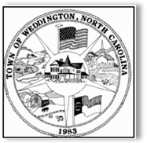
TOWN OF WEDDINGTON
Town Council Meeting Agenda
2019 Retreat
Rolling Hills Country Club
2722 West Roosevelt Blvd
Monroe, NC 28110

Friday, February 7, 2020 –9:00 a.m.

Welcome and Agenda Review
Adoption of the agenda

- Introductions
2. Planning
a. ETJ and Donut Holes
- Unified Development Ordinance
c. Stormwater/Tree Ordinance
d. Possible Text Amendments
- Rules of Procedure/PB Terms
- Downtown Overlay
  - Sewer to the Downtown
  - Park Options
  - Uses
  - Medians/Other Improvements

LUNCH BREAK

4. Transportation
- Transportation Planning Funds
- Forest Lawn/Potter

5. Public Safety
- Deputy Contract
- Fire Agreement

6. Administrative Items
- Events
- Communication
- Policies

7. Branding
- Signage
- Brand Book and Logo

8. Finance
a. FY 2020-2021 Prelim Budget Discussion

9. Review Key Objectives and Assignments

10. Adjournment

