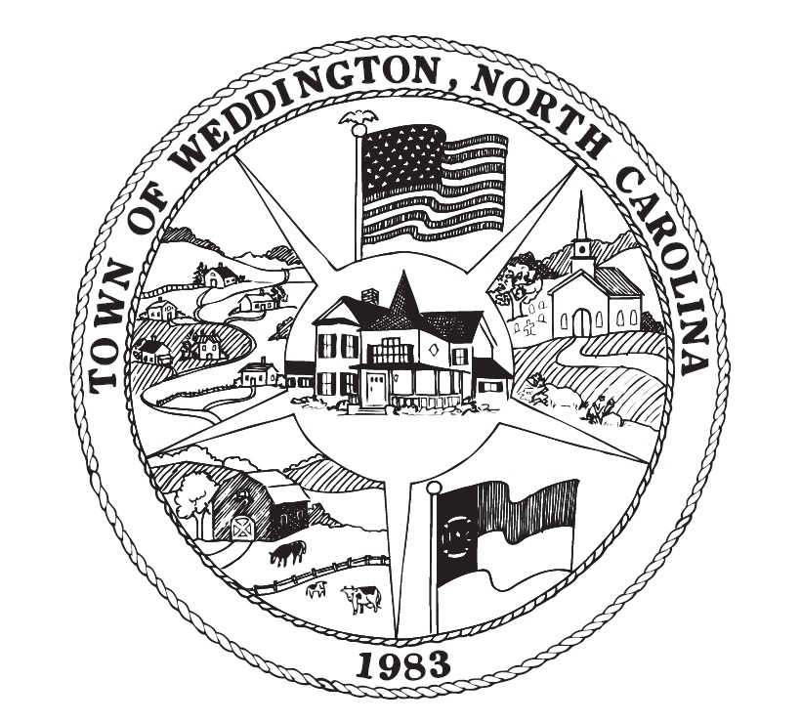

Town of Weddington
Notice of Public Hearing

Notice is hereby given that a public hearing will be held by the Planning Board of the Town of Weddington at the Weddington Town Hall, 1924 Weddington Road, Weddington NC on Monday, September 23, 2019 at 7:00 p.m., for the purpose of considering a Temporary Use Permit for the Weddington Optimist Club to hold a centennial celebration on Saturday, October 19, 2019 from 5:00 p.m. to 9:00 p.m. at Optimist Park 5211 Weddington Road, Weddington, NC.

A copy of the Temporary Use Permit application is available in the Town Planner’s Office for inspection by all interested citizens.

The Town of Weddington does not discriminate based on disability. Individuals requiring auxiliary aids or services or other accommodations for participation in a meeting may contact Karen Dewey at 704-846-2709. Requests should be made at least 4 days prior to the meeting.”

