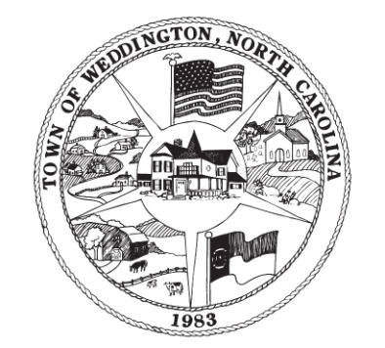

TOWN OF WEDDINGTON
NOTICE OF PUBLIC HEARING

Notice is hereby given that a Public Hearing will be held by the Planning Board of the Town of Weddington at the Weddington Town Hall, 1924 Weddington Road, Weddington NC on October 22, 2018 at 7:00 p.m., for the purpose of considering the following:

Review and Consideration of a Temporary Use Permit Application for the Independence on the Farm Event to be held on the Hunter Farm property from 3:00-7:00 pm on Saturday, November 17, 2018.

The public is encouraged to be present for this meeting. A copy of the Temporary Use Permit Application is on file in the Town Planner’s Office for inspection by all interested citizens.

“In accordance with Title II of the Americans with Disabilities Act (ADA), the Town of Weddington does not discriminate on the basis of disability in conducting its meetings. Individuals with disabilities who require auxiliary aids or services or other accommodations for effective communication and participation in a meeting may contact the Town Clerk at 704-846-2709. Requests should be made at least 4 days prior to the meeting.”

