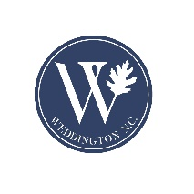
Town of Weddington
Regular Town Council Work Session
Tuesday, June 20, 2023 – 12 noon
Weddington Town Hall
1924 Weddington Road Weddington, NC 28104
Agenda

- Call to Order
- Determination of Quorum
- Additions, Deletions and/or Adoption of the Agenda
- Conflict of Interest Statement: In accordance with the state government ethics act, it is the duty of every Council member to avoid conflicts of interest. Does any Council member have any known conflict of interest with respect to any matters on the agenda? If so, please identify the conflict and refrain from any participation in the matter involved.
- Old Business
  - Presentation by Union County Library Foundation
  - Discussion Fiscal Year 2023-2024 Proposed Budget
    - Consideration of Fiscal Year 2023-2024 Proposed Budget and Budget Ordinance O-2023-05 and set the tax rate.
- Council Comments and Review Action Items
- Adjournment

