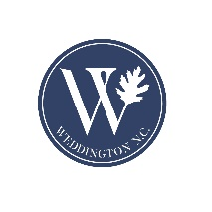
Town of Weddington
Special Town Council Meeting
Monday, May 1, 2023 – 8:00 a.m.
Weddington Town Hall
1924 Weddington Road, Weddington, NC 28104
Agenda

- Call to Order

- Determination of Quorum

- Additions, Deletions and/or Adoption of the Agenda

- Conflict of Interest Statement: In accordance with the state government ethics act, it is the duty of every Council member to avoid conflicts of interest. Does any Council member have any known conflict of interest with respect to any matters on the agenda? If so, please identify the conflict and refrain from any participation in the matter involved.

- Discussion and Consideration of R 2023-05 Resolution to the North Carolina General Assembly regarding Union County Sewer and Water Infrastructure

- Council Comments

- Adjournment

